PAN Localization Project
Science Technology and Environment Agency of Lao PDR
National University Computer and Emergency Science of Pakistan
International Development Research Center

Syllabification of Lao Script for Line Breaking

Phonpasit PHISSAMAY, National Project Director
Valaxay DALALOY, National Project Coordinator
Nadir DURRANI, Project consultant
Dr. Sarmad Hussain, Regional Project Director
(Ms. Oulaiphone SILIMASAK);
(Ms. Chitthaphone CHANHSILILATH);
(Mr. Khamphay INTHARA);
(Mr. Phonexay VILAKONE);

- Definition:
Lines are broken as result of one of two conditions. The first condition is the presence of an explicit line breaking character. The second condition results from a formatting algorithm having selected among available line break opportunities; ideally the chosen line break results in the optimal layout of the text.
Different formatting algorithms may use different methods to determine an optimal line break. For example, simple implementations consider a single line at a time, trying to find a locally optimal line break. A basic, yet widely used approach is to allow no compression or expansion of the inter-character and inter-word spaces and consider the longest line that fits. When compression or expansion is allowed, a locally optimal line break seeks to balance the relative merits of the resulting amounts of compression and expansion for different line break candidates.
When expanding or compressing inter-word space according to common typographical practice, only the spaces marked by U+0020 SPACE, U+00A0 NO-BREAK SPACE, and U+3000 IDEOGRAPHIC SPACE are subject to compression, and only spaces marked by U+0020 SPACE, U+00A0 NO-BREAK SPACE, and occasionally spaces marked by U+2009 THIN SPACE are subject to expansion. All other space characters normally have fixed width. When expanding or compressing inter-character space the presence of U+200B ZERO WIDTH SPACE or U+2060 WORD JOINER is always ignored.
Three principal styles of context analysis determine line break opportunities.
- Western — spaces and hyphens are used to determine breaks: It is commonly used for scripts employing the space character. Hyphenation is often used with space-based line breaking to provide additional line break opportunities. However, it requires knowledge of the language and in addition; it may need user interaction or overrides.
- East Asian — lines can break anywhere, unless prohibited: In these scripts, lines can break anywhere, except before or after certain characters. The precise set of prohibited line breaks may depend on user preference or local custom and is commonly tailorable.
- South East Asian — line breaks require morphological analysis: The third style is used for scripts such as Lao, which do not use spaces, but which restrict word-breaks to syllable boundaries, the determination of which requires knowledge of the language comparable to that required by a hyphenation algorithm. Such an algorithm is beyond the scope of the Unicode Standard.
- Syllabification of Lao Script

Introduction

Syllable is a unit of spoken language, which may have a common meaning or not. A unit of spoken language may have one single syllable or many syllables. Additional complexity is introduced by lack of a space character. Though humans can process multiword string while reading and extract words from it, this process is very difficult for computers. However, unless words can be separated, it is impossible to perform even the simple task of determining how to break at the end of a typed line when characters exceed the line length, without the possibility of breaking between a word and worse between syllables.

In Lao language, the breaking of the text flow after each word (like in English) is not common. One possible way line breaking can be achieved in Lao is to use a Lao lexicon which is currently incompletion. Lao collation is complex because it does not sort on key-press order but on basis of its intricate syllable structure. Thus, before any processing is done, a Lao character string has to be syllabified. This paper develops a Lao string syllabification algorithm. This algorithm is essential for processing basic input character string to enable more advanced language processing including searching, sorting, line breaking and lexical development.

Lao Character Set

Lao syllable structure contains characters and marks for consonants, vowels and tones. Table 1 below lists these possible characters and marks. The marks are combining characters and are shown adjacent to ‘x’, latter representing a consonant. Character names and their Unicode is also given (ref. to Unicode)

Table 1: Lao Characters

    - Vowels (‘x’ is a placeholder for a consonant character)

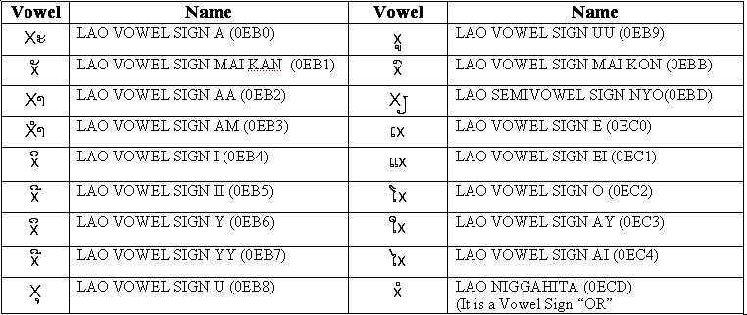

- Consonants (‘x’ marks a placeholder for a consonant character)

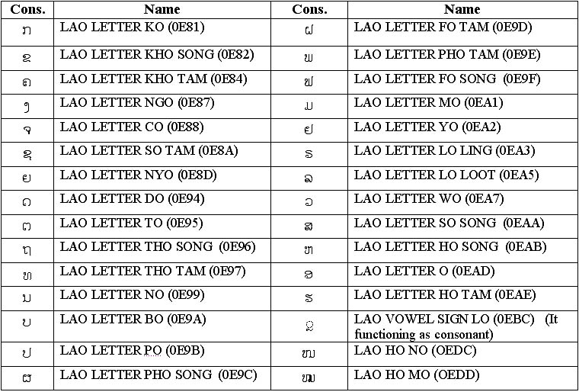

- Tones (‘x’ is a placeholder for a consonant character)

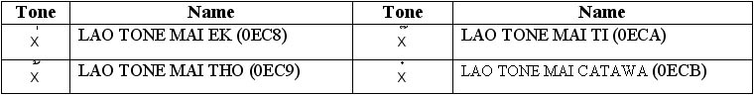

- Sign (‘x’ is a placeholder for a alternate consonant character)

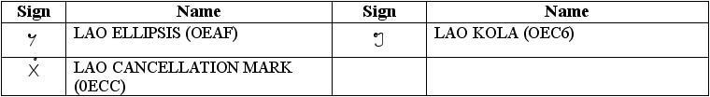

Table 1 shows there are 18 vowel marks and characters, 30 character marks and characters, 4 tonal marks and 3 special symbols. Vowels can occur before, above, below a consonantal character or on the baseline. Characters occur on the baseline. Tonal marks always occur on top of consonantal characters.

Basic Syllable Structure

Lao language writing system is based on a central or nuclear consonantal character. This consonant may have optionally vowel character or marks around it (before, after, above or below). In addition, this nuclear consonantal character may also have optional a tonal mark above it and optionally more consonantal characters following it. This is illustrated in Figure 1 below. Capital C indicates the nuclear consonantal character. The subscripts indicate that all are optional except the nucleus C.
 |  | t_{0,1}
 |  | v_{0,1}
V_{0,1} | c_{0,1} | C | v_{0,1} | c_{0..4}
 |  | c_{0,1}
 |  | v_{0,1}

Constraints on Syllable Structure

Not all characters and marks are allowed at all the placeholders shown in Figure 1. Figure 2 and Table 2 below collectively further classify these consonants, vowels and tones to indicate these limitations. The number n in Xn represents the key-press order or typing sequence of these characters and marks relative to each other, except X (which is typed between X1 and X2). Thus tone is typed after the initial vowel X0, consonant X1, nucleus X, and vowel mark X3 and X4 (if X0, X1 and X2 are not null; X can never be null).

 |  | X5
 |  | X4
X0 | X1 | X | X6 | X7 | X8 | X9 | X10
 |  | X2
 |  | X3

The following table is shown the characters exist in each structure position
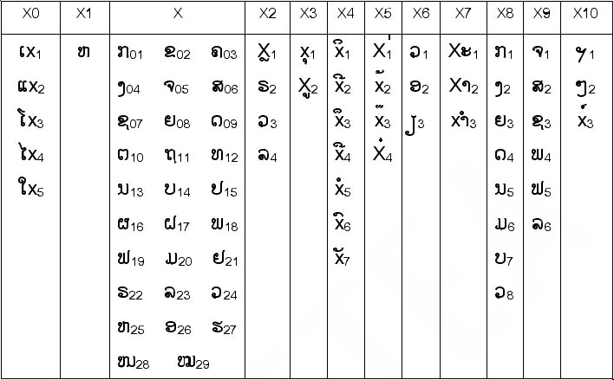

- X0 represents a vowel which occurs before the nuclear consonant. It is can always defined the beginning of syllable.
- X1 is a combination consonant which comes before the nuclear consonant, only if nuclear consonant is one of .
- X is represents the nuclear consonants.
- X2 is a combination consonant which comes after the nuclear consonant, which placing under or next to the nuclear consonant.
- X​3 is represents a vowel which occurs under the nuclear consonant.
- X4 is represents a vowel which occurs upper the nuclear consonant.
- X​5 is represents a tone marks which occurs upper the nuclear consonant or upper vowels.
- X6 is represents consonant vowel, which occurs after nuclear consonant. It functions when the syllable doesn’t have any vowels. And it always exists with X8.
- X7 is represents an after vowels. However X7₁ is always represents the end of syllable and it is never exist with tone mark.
- X8 is represents alternate consonants.
- X9 is represents alternate consonant to pronounce foreign language, it always exist with X10₃.
- X10 represents a sign mark. X10 is always occurs at the end of syllable, but mostly people keep it separate from syllable.

The nuclear consonant always exists in syllable with some vowel or alternate consonants. The position at which vowels appear can guide to define the beginning and end of each syllable. Using following rules we can find potential syllable boundary.

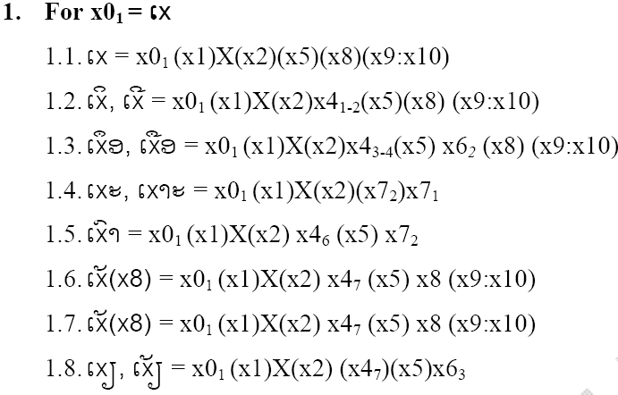

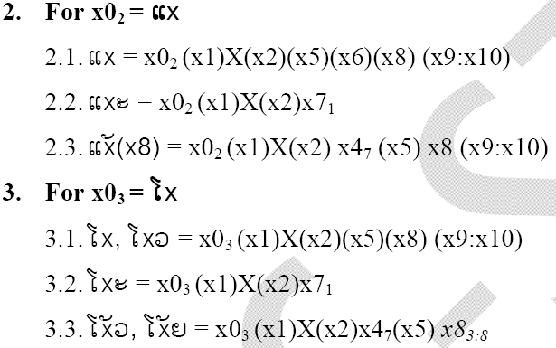
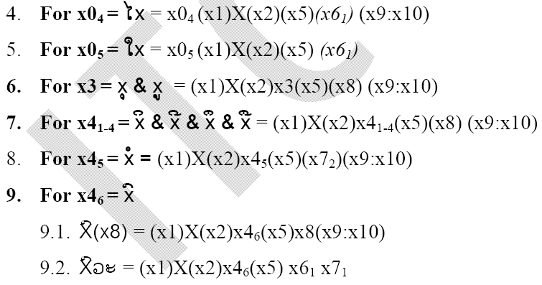
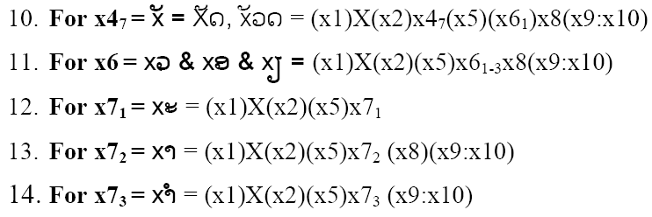

Lao Syllabification Algorithm

Lao Syllabification algorithm can be defined as follows:

- Traverse through the input array and mark syllable boundary as soon as you encounter a punctuation mark, space or a character that does not belong to Lao character set. Example:
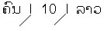
Syllable (boundaries due to non-Lao character)

- Filter out Lao characters out of input array leaving behind punctuation marks, spaces, and non-Lao characters. Example:

- Reorder character in case of typing variations (Sometime people maybe typed X5 before X2, X3, X4 and X4 maybe typed before X2). Example:
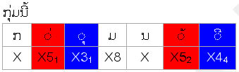

Syllable In this case: X3₁ should typed before X5₁ and X4₄ should typed before X5₂

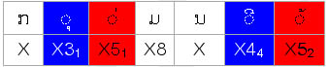

- Mark each character in run with all possible X_{n} values it can take. Example:

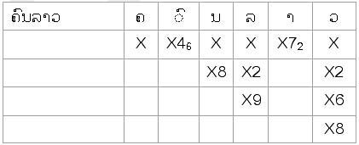

- Use rules discussed in previous section to find out syllable boundaries.
  - In case if more then one condition suggests a syllable boundary chose the one with longest run.
  - In case none of the conditions suggest syllable boundary try including last character from previous syllable to current syllable.
  - Test all the conditions for previous syllable because removing last character might make it invalid. If it is still a valid syllable then try conditions starting from newly added character, other wise restore the previous syllable and skip first character from current syllable and try testing from next character. Keep skipping characters till find a valid syllable boundary.
  - If program finds boundary for the new syllable it should continue naturally other wise restore previously disturbed syllable by putting back the removed character. Skip the current characters and re-test the conditions, keep skipping unless you find valid syllable.
For example: -In case of 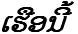program should identify syllable boundary like
then it would be unable to detect any condition working for so it should shift syllable boundary one step back and try to include ‘’ with . But before testing this new syllable it should test the previous syllable and find if it is still a valid syllable which in the current scenario is a valid syllable. Now try testing for this is also a valid syllable so program would continue naturally and go for testing next syllable.

Now consider this example 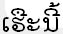 program suggests syllable boundary after now as we try test 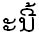 we would find none of the conditions working so we try to remove from previous syllable and test if is still a valid. In case it is we test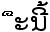 we still find none of the conditions working so we restore previous syllable skip current character and carry on testing conditions from Keep skipping characters unless you find valid syllable. In the current example you only have to skip it once.

- Traverse till the end of array.

- Put the Lao characters back into original array that have punctuation marks and other non-Lao characters.

Example 1: ໂຄງການL10Nພັ່ດທະນາພາສາລາວ
- Step 1 & 2: Traverse through the input array mark syllable boundary where counter non-Lao character. Extract only Lao text and put it in new array.
ໂຄງການ | ພັÈດທະນາພາສາລາວ
- Step 3: Look for possible re-ordering of text. For example user might type ‘ È’ X5 before ‘ × ’ X47 so we must do the re-ordering.
- Step 4: Mark each character with possible X_{N.}

ໂ | ຄ | ງ | ກ | າ | ນ | B1 | ພ | ັ | ່ | ດ | ທ | ະ | B1 | ນ | າ | ພ | າ | ສ | າ | ລ | າ | ວ
A0 | A1 | A2 | A3 | A4 | A5 | A6 | A7 | A8 | A9 | A10 | A11 | A12 | A13 | A14 | A15 | A16 | A17 | A18 | A19 | A20 | A21 | A22
X0₃ | X₀₃ | X₀₄ | X₀₁ | X7₂ | X₁₃ |  | X₁₈ | X4₇ | X5 | X₀₉ | X₁₂ | X7₁ |  | X₁₃ | X7₂ | X₁₈ | X7₂ | X₀₆ | X7₂ | X₂₃ | X7₂ | X₂₄
 |  | X8₂ | X8₁ |  | X8₅ |  | X9₄ |  |  | X8₄ |  |  |  | X8₅ |  | X9₄ |  | X9₂ |  | X2₄ |  | X2₃
 |  |  |  |  |  |  |  |  |  |  |  |  |  |  |  |  |  |  |  | X9₆ |  | X6₁
 |  |  |  |  |  |  |  |  |  |  |  |  |  |  |  |  |  |  |  |  |  | X8₈

- Step 5: Use rules and conditions discussed above to define syllable boundaries.

Rule 3.1 Rule 13 Rule 10 Rule 12 Rule 13 Rule 13 Rule 13 Rule 13
ໂ | ຄ | ງ |  | ກ | າ | ນ |  | ພ | ັ | ່ | ດ |  | ທ | ະ |  | ນ | າ |  | ພ | າ |  | ສ | າ |  | ລ | າ | ວ
A0 | A1 | A2 |  | A3 | A4 | A5 |  | A7 | A8 | A9 | A10 |  | A11 | A12 |  | A14 | A15 |  | A16 | A17 |  | A18 | A19 |  | A20 | A21 | A22

- Step 6: Put the Lao characters back into original array.
- Step 1 & 2: Traverse through the input array mark syllable boundary where counter non-Lao character. Extract only Lao text and put it in new array.
- Step 3: Look for possible re-ordering of text. For example user might type X5 before X47 so we must do the re-ordering.

- Step 4: Mark each character with possible X_{N.}
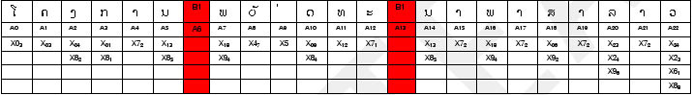
- Step 5: Use rules and conditions discussed above to define syllable boundaries.

Rule 3.1 Rule 13 Rule 10 Rule 12 Rule 13 Rule 13 Rule 13 Rule 13
- Step 6: Put the Lao characters back into original array.

- Lao Line Breaking Utility

Screen Dumps

Given below are some screen shots that might be helpful in facilitating the understanding.

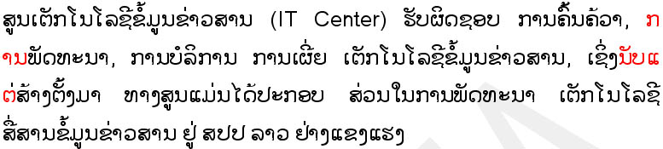

Highlighted text represents the problem. Word is unable to break the line properly due to the continuum of words without any space or any other clue which can be used to decide where to break the line. .We have to insert these clues inform of zero width space.

For instance in first-second lines consider since there is no space for remaining in the currently line word shifts it to next line blindly without realizing that it was part of . However, if there were a zero width space in between 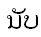 and then it would shift whole syllable to next line. Similar is the case with 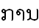 in line number first where being part of the syllable is dragged to next line.

User can browser for the file and let the program read the input and do the rest.

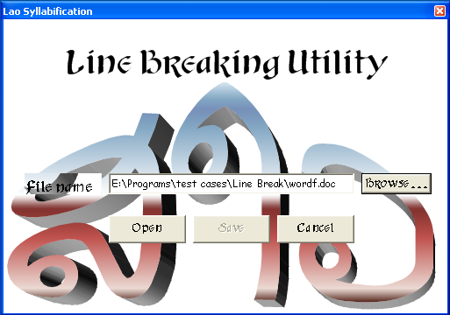

Program displays a success message and prompts the user to save the modified file with new name or replace the existing after which the output file is displayed automatically.

Output file:

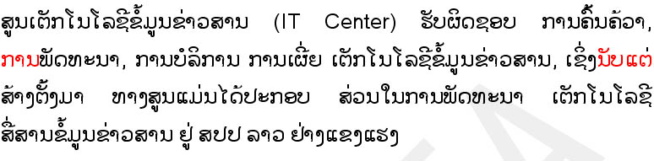

As you can see that syllable boundaries are now properly defined as word finds the zero width space after every syllable which provides it help to properly segment the words and break the line properly. If we put a space between and it would not shift only but complete syllable to the next line as shown below.

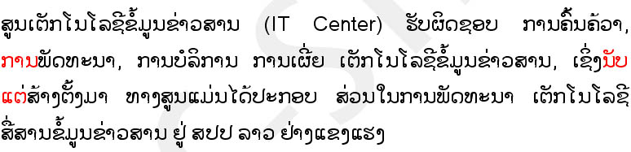
And as you can see there is a corresponding adjustment in line three where entire syllable 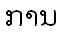 moves onto next line.

